**TUGAS UAS PRAKTIKUM**

**APLIKASI ADMIN STATUS**



NAMA KELOMPOK:

Fahrudin Yusuf Habibi(140403020020)

Iwan Hadi Prasetyo(140403020034)

Yusuf Rachmad Darmawan(140403020031)

Agam Budi Waluyo(140403020013)

1. **Latar BELAKANG**

Seiring dengan kemajuan teknologi yang mengglobal telah terpengaruh dalam segala aspek kehidupan baik di bidang ekonomi, politik, kebudayaan, seni dan bahkan di dunia pendidikan. Kemajuan teknologi adalah sesuatu yang tidak bisa kita hindari dalam kehidupan ini, karena kemajuan teknologi akan berjalan sesuai dengan kemajuan ilmu pengetahuan. Setiap inovasi diciptakan untuk memberikan manfaat positif bagi kehidupan manusia. Memberikan banyak kemudahan, serta sebagai cara baru dalam melakukan aktifitas manusia. Khusus dalam bidang teknologi informasi sudah menikmati banyak manfaat yang dibawa oleh inovasi-inovasi yang telah dihasilkan dalam dekade terakhir ini. Namun demikian, walaupun pada awalnya diciptakan untuk menghasilkan manfaat positif, di sisi lain juga memungkinkan digunakan untuk hal negatif.

Dalam kehidupan sehari-hari penggunaan teknolgi pasti kita tidak jauh dengan namanya media social, disini bisanya sering sekali membuat status yang kita tidak tau kalau itu melanggar udang-undang ITE yang berlaku.

1. **RUMUSAN MASALAH**
2. Cara mencegah kegitan kita di media social yang melanggar udang-undang ?
3. **TUJUAN**
4. mencegah kegitan kita di media social yang melanggar udang-undang.
5. **ISI**
6. Screen Shot

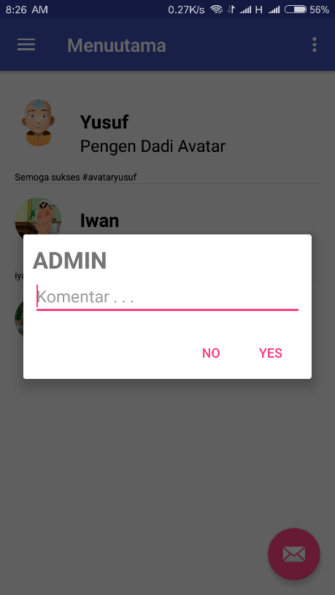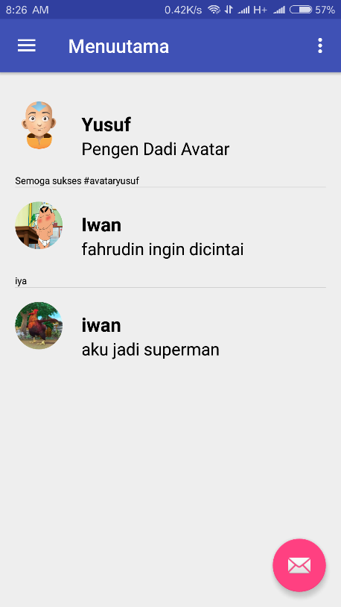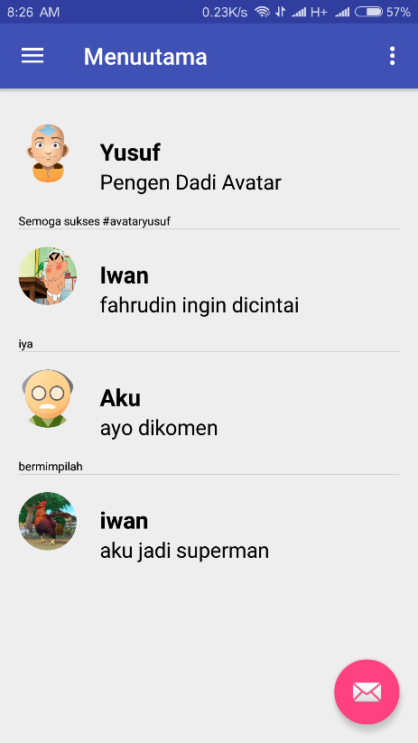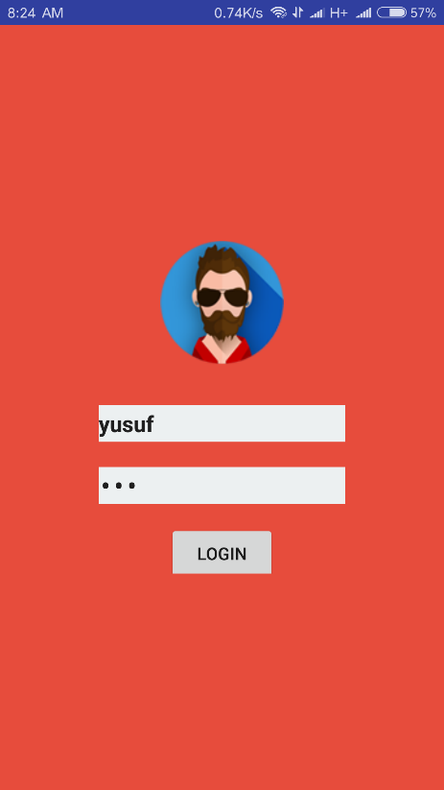

1. **Script**
2. Adapter

**public class** adapter **extends** ArrayAdapter<Data_status> {  
  
 String **url**=**"http://uasmobile.esy.es/mobile/fotone/"**;  
 **private** Context **context**;  
 **private** List<Data_status> **statusList**;  
  
 **public** adapter(Context context, **int** resource, List<Data_status> objects) {  
 **super**(context, resource, objects);  
 **this**.**context** = context;  
 **this**.**statusList** = objects;  
 }  
  
 @Override  
 **public** View getView(**int** position, View convertView, ViewGroup parent) {  
 LayoutInflater inflater = (LayoutInflater) **context**.getSystemService(Activity.***LAYOUT_INFLATER_SERVICE***);  
 View view = inflater.inflate(R.layout.***list_status***,parent,**false**);  
 Data_status flower = **statusList**.get(position);  
 TextView tv = (TextView) view.findViewById(R.id.***name***);  
 tv.setText(flower.getName());  
 TextView tv1 = (TextView) view.findViewById(R.id.***status***);  
 tv1.setText(flower.getStatus());  
 TextView tv2 = (TextView) view.findViewById(R.id.***komentare***);  
 tv2.setText(flower.getKomentar());  
 ImageView img = (ImageView) view.findViewById(R.id.***img***);  
 Picasso.*with*(getContext()).load(**url**+flower.getfoto()).resize(150,150).into(img);  
 **return** view;  
 }  
  
  
}

1. AdapterStatuse

**public class** AdapterStatuse **extends** ArrayAdapter<Status> {  
  
 String **url**=**"http://uasmobile.esy.es/mobile/fotone/"**;  
 **private** Context **context**;  
 **private** List<Status> **statusList**;  
  
  
 **public** AdapterStatuse(Context context, **int** resource, List<Status> objects) {  
 **super**(context, resource, objects);  
  
 **this**.**context** = context;  
 **this**.**statusList** = objects;  
  
 }  
  
 @Override  
 **public** View getView(**int** position, View convertView, ViewGroup parent) {  
 LayoutInflater inflater = (LayoutInflater) **context**.getSystemService(Activity.***LAYOUT_INFLATER_SERVICE***);  
 View view = inflater.inflate(R.layout.***row_items***,parent,**false**);  
 Status st = **statusList**.get(position);  
 TextView tv = (TextView) view.findViewById(R.id.***textView***);  
 tv.setText(st.getNama());  
 ImageView img = (ImageView) view.findViewById(R.id.***imageView***);  
 Picasso.*with*(getContext()).load(**url**+st.getFoto()).resize(100,100).into(img);  
 **return** view;  
 }  
}

1. Api

**public interface** api {  
  
 @GET(**"/mobile/parsing.php"**)  
 **public void** getData(Callback<List<Data_status>> response);  
  
}

1. BacaData

**public interface** BacaData {  
  
 @FormUrlEncoded  
 @POST(**"/mobile/login.php"**)  
  
 **public void** bacadata(  
 @Field(**"Nama"**) String Nama,  
 @Field(**"Password"**) String Password,  
 Callback<Response> callback  
 );  
  
  
}

1. BacaStatus

**public interface** BacaStatus {  
  
  
 @GET(**"/mobile/parsing.php"**)  
 **public void** getStatus(Callback<List<Status>> response);  
  
}

1. Beranda

**public class** Beranda **extends** Fragment **implements** interface_komentar, interface_hapus_status {  
  
 **private** List<Data_status> **datas**;  
 String **url** = **"http://uasmobile.esy.es/"**;  
 String **id_komentar**;  
 **int baris**;  
 **int baris1**;  
  
  
 @Nullable  
 @Override  
 **public** View onCreateView(LayoutInflater inflater, @Nullable ViewGroup container, @Nullable Bundle savedInstanceState) {  
 **return** inflater.inflate(R.layout.***activity_beranda***, container, **false**);  
  
 }  
  
 @Override  
 **public void** onActivityCreated(@Nullable Bundle savedInstanceState) {  
 **super**.onActivityCreated(savedInstanceState);  
 status();  
 }  
  
 **public void** status (){  
  
 **final** RestAdapter restadapter = **new** RestAdapter.Builder().setEndpoint(**"http://uasmobile.esy.es"**).build();  
  
 api flowerapi = restadapter.create(api.**class**);  
  
 flowerapi.getData(**new** Callback<List<Data_status>>() {  
 @Override  
 **public void** success(List<Data_status> flowers, Response response) {  
 **datas** = flowers;  
 View view = getView();  
  
 adapter adapt = **new** adapter(getContext().getApplicationContext(),R.layout.***list_status***,**datas**);  
 ListView listView = (ListView)view.findViewById(R.id.***list***);  
  
 listView.setAdapter(adapt);  
  
  
*// click action* listView.setOnItemClickListener(**new** AdapterView.OnItemClickListener() {  
 @Override  
 **public void** onItemClick(AdapterView<?> adapterView, View view, **int** postion, **long** l) {  
  
 **baris** = postion+1;  
  
 LayoutInflater layoutInflater = LayoutInflater.*from*(getContext());  
 View view1 = layoutInflater.inflate(R.layout.***input_dialog***,**null**);  
 **final** EditText ed_input = (EditText)view1.findViewById(R.id.***editText***);  
  
  
 AlertDialog.Builder alertDialogBuilder = **new** AlertDialog.Builder(getContext());  
 alertDialogBuilder  
 .setView(view1)  
 .setCancelable(**false**)  
 .setPositiveButton(**"Yes"**,**new** DialogInterface.OnClickListener() {  
 **public void** onClick(DialogInterface dialog,**int** id) {  
 *// if this button is clicked, close  
 // current activity* **id_komentar** = ed_input.getText().toString();  
 Toast.*makeText*(getContext(),**"Komentar dibaris : "**+**baris**,Toast.***LENGTH_LONG***).show();  
 insert_komen();  
  
 }  
 })  
 .setNegativeButton(**"No"**,**new** DialogInterface.OnClickListener() {  
 **public void** onClick(DialogInterface dialog,**int** id) {  
 *// if this button is clicked, just close  
 // the dialog box and do nothing* dialog.cancel();  
 }  
 });  
  
 *// create an alert dialog* AlertDialog alert = alertDialogBuilder.create();  
 alert.show();  
 }  
 });  
*// ends click action  
  
// long click action* listView.setOnItemLongClickListener(**new** AdapterView.OnItemLongClickListener() {  
 @Override  
 **public boolean** onItemLongClick(AdapterView<?> adapterView, View view, **int** i, **long** l) {  
 **baris1** = i+1;  
 hapus_status();  
 Toast.*makeText*(getContext(),**"Hapus Data : "**+**baris1**,Toast.***LENGTH_LONG***).show();  
 **return true**;  
 }  
 });  
*// ends click action* }  
  
 @Override  
 **public void** failure(RetrofitError error) {  
 Toast.*makeText*(getContext().getApplicationContext(),**"Gagal"**,Toast.***LENGTH_SHORT***).show();  
 }  
 });  
 }  
  
 **private void** insert_komen(){  
 *//Here we will handle the http request to insert user to mysql db  
 //Creating a RestAdapter* RestAdapter adapter = **new** RestAdapter.Builder()  
 .setEndpoint(**url**) *//Setting the Root URL* .build(); *//Finally building the adapter  
  
 //Creating object for our interface* interface_komentar api = adapter.create(interface_komentar.**class**);  
  
 *//Defining the method insertuser of our interface* api.insert_komen(  
  
 **id_komentar**,  
 **baris**,  
  
 *//Creating an anonymous callback* **new** Callback<Response>() {  
 @Override  
 **public void** success(Response result, Response response) {  
 *//On success we will read the server's output using bufferedreader  
 //Creating a bufferedreader object* Log.*e*(**"sukses : "**,response.toString());  
 BufferedReader reader = **null**;  
  
 *//An string to store output from the server* String output = **""**;  
  
 **try** {  
 *//Initializing buffered reader* reader = **new** BufferedReader(**new** InputStreamReader(result.getBody().in()));  
  
 *//Reading the output in the string* output = reader.readLine();  
 } **catch** (IOException e) {  
 e.printStackTrace();  
 }  
  
 *//Displaying the output as a toast* Toast.*makeText*(getContext(), output, Toast.***LENGTH_LONG***).show();  
 }  
  
 @Override  
 **public void** failure(RetrofitError error) {  
 *//If any error occured displaying the error as toast* Toast.*makeText*(getContext(), error.toString(),Toast.***LENGTH_LONG***).show();  
 Log.*e*(**"error : "**,error.toString());  
 }  
 }  
 );  
 }  
  
 **public void** hapus_status(){  
  
 *//Here we will handle the http request to insert user to mysql db  
 //Creating a RestAdapter* RestAdapter adapter = **new** RestAdapter.Builder()  
 .setEndpoint(**url**) *//Setting the Root URL* .build(); *//Finally building the adapter  
  
 //Creating object for our interface* interface_hapus_status api = adapter.create(interface_hapus_status.**class**);  
  
 *//Defining the method insertuser of our interface* api.delete_status(  
  
 **baris1**,  
  
  
 *//Creating an anonymous callback* **new** Callback<Response>() {  
 @Override  
 **public void** success(Response result, Response response) {  
 *//On success we will read the server's output using bufferedreader  
 //Creating a bufferedreader object* Log.*e*(**"sukses : "**,response.toString());  
 BufferedReader reader = **null**;  
  
 *//An string to store output from the server* String output = **""**;  
  
 **try** {  
 *//Initializing buffered reader* reader = **new** BufferedReader(**new** InputStreamReader(result.getBody().in()));  
  
 *//Reading the output in the string* output = reader.readLine();  
 } **catch** (IOException e) {  
 e.printStackTrace();  
 }  
  
 *//Displaying the output as a toast* Toast.*makeText*(getContext(), output, Toast.***LENGTH_LONG***).show();  
 }  
  
 @Override  
 **public void** failure(RetrofitError error) {  
 *//If any error occured displaying the error as toast* Toast.*makeText*(getContext(), error.toString(),Toast.***LENGTH_LONG***).show();  
 Log.*e*(**"error : "**,error.toString());  
 }  
 }  
 );  
  
 }  
  
  
 @Override  
 **public void** insert_komen(@Field(**"komentar"**) String komentar, @Field(**"id_status"**) **int** id_status, Callback<Response> callback) {  
  
 }  
  
 @Override  
 **public void** delete_status(@Field(**"id_status"**) **int** id_status, Callback<Response> callback) {  
  
 }  
}

1. DaftarStatus

**private** ArrayList<Model> **data_model**;  
  
  
 @Nullable  
 @Override  
 **public** View onCreateView(LayoutInflater inflater, @Nullable ViewGroup container, @Nullable Bundle savedInstanceState) {  
 **return** inflater.inflate(R.layout.***daftar_status***, container, **false**);  
 }  
  
 @Override  
 **public void** onActivityCreated(@Nullable Bundle savedInstanceState) {  
 **super**.onActivityCreated(savedInstanceState);  
  
 initUI();  
 }  
  
 **private void** initUI(){  
 View view = getView();  
 RecyclerView recyclerView = (RecyclerView)view.findViewById(R.id.***recylerView***);  
  
 RecyclerView.LayoutManager lm = **new** LinearLayoutManager(getContext());  
 recyclerView.setLayoutManager(lm);  
  
 **data_model** = **new** ArrayList<>();  
 **for** (**int** i = 0; i < MyData.*nama_array*.**length**; i++) {  
 **data_model**.add(**new** Model(  
 MyData.*nama_array*[i],  
 MyData.*status_array*[i],  
 MyData.*gambar_array*[i]  
 ));  
 }  
  
 RecyclerView.Adapter adapter = **new** DataAdapter(**data_model**);  
 recyclerView.setAdapter(adapter);  
  
  
  
  
 }  
}

1. Data_Status

**public** String getKomentar() {  
 **return komentar**;  
 }  
  
 **public void** setKomentar(String komentar) {  
 **this**.**komentar** = komentar;  
 }  
 **public int** getId_status() {  
 **return id_status**;  
 }  
 **public void** setId_status(**int** id_status) {  
 **this**.**id_status** = id_status;  
 }  
 **public** String getName() {  
 **return nama**;  
 }  
 **public void** setName(String name) {  
 **this**.**nama** = name;  
 }  
 **public** String getStatus() {  
 **return status**;  
 }  
 **public void** setStatus(String status) {  
 **this**.**status** = status;  
 }  
 **public** String getfoto() {  
 **return foto**;  
 }  
 **public void** setfoto(String foto) {  
 **this**.**foto** = foto;  
 }  
 **public** Bitmap getBitmap() {  
 **return bitmap**;  
 }  
 **public void** setBitmap(Bitmap bitmap) {  
 **this**.**bitmap** = bitmap;  
 }  
  
  
}

1. DataAdapter

**public class** DataAdapter **extends** RecyclerView.Adapter<DataAdapter.ViewHolder> {  
  
 **private** ArrayList<Model> **data_set**;  
  
 **public** DataAdapter(ArrayList<Model> data_model){  
 **this**.**data_set** = data_model;  
 }  
  
  
 @Override  
 **public** ViewHolder onCreateViewHolder(ViewGroup parent, **int** viewType) {  
 View view = LayoutInflater.*from*(parent.getContext()).inflate(R.layout.***row_items***,parent,**false**);  
 **return new** ViewHolder(view);  
 }  
  
 @Override  
 **public void** onBindViewHolder(ViewHolder holder, **int** position) {  
 holder.**tv_nama**.setText(**data_set**.get(position).getNama());  
 holder.**tv_status**.setText(**data_set**.get(position).getStatus());  
 holder.**img_profil**.setImageResource(**data_set**.get(position).getGambar());  
 }  
  
 @Override  
 **public int** getItemCount() {  
 **return data_set**.size();  
 }  
  
 **public class** ViewHolder **extends** RecyclerView.ViewHolder{  
  
 TextView **tv_nama**, **tv_status**;  
 ImageView **img_profil**;  
  
 **public** ViewHolder(View itemView) {  
 **super**(itemView);  
  
 **tv_nama** = (TextView)itemView.findViewById(R.id.***textView***);  
 **tv_status** = (TextView)itemView.findViewById(R.id.***textView1***);  
 **img_profil** = (ImageView)itemView.findViewById(R.id.***imageView***);  
  
 itemView.setOnClickListener(**new** View.OnClickListener() {  
 @Override  
 **public void** onClick(View view) {  
 **int** posisi = getAdapterPosition();  
 Toast.*makeText*(view.getContext(),**"on click item : "**+posisi,Toast.***LENGTH_LONG***).show();  
 }  
 });  
 }  
 }  
}

1. Interface_hapus_status

**public interface** interface_hapus_status {  
 @FormUrlEncoded  
 @POST(**"/mobile/delete.php"**)  
 **public void** delete_status(  
 @Field(**"id_status"**) **int** id_status,  
 Callback<Response> callback  
 );  
  
  
}

1. Interface_Komentar

**public interface** interface_komentar {  
 @FormUrlEncoded  
 @POST(**"/mobile/insert_komen.php"**)  
 **public void** insert_komen(  
 @Field(**"komentar"**) String komentar,  
 @Field(**"id_status"**) **int** id_status,  
 Callback<Response> callback  
 );  
  
  
}

1. MainActivity

**public class** MainActivity **extends** Activity {  
  
  
 **private** EditText **tvNama**;  
 **private** EditText **tvPassword**;  
 **public static final** String ***Alamat*** = **"http://uasmobile.esy.es/"**;  
  
  
  
 @Override  
 **protected void** onCreate(Bundle savedInstanceState) {  
 **super**.onCreate(savedInstanceState);  
 setContentView(R.layout.***activity_main***);  
  
 **tvNama** = (EditText)findViewById(R.id.***Nama_Anda***);  
 **tvPassword**= (EditText)findViewById(R.id.***Password_Anda***);  
  
 }  
 **public void** proses (View view){  
  
 RestAdapter adapter = **new** RestAdapter.Builder().setEndpoint(***Alamat***).build();  
  
 BacaData baca = adapter.create(BacaData.**class**);  
  
 baca.bacadata(  
 **tvNama**.getText().toString(),  
 **tvPassword**.getText().toString(),  
  
 **new** Callback<Response>() {  
  
 @Override  
 **public void** success(Response result, Response response) {  
 BufferedReader bacapesan =**null**;  
 String keluaran = **""**;  
 **try** {  
 bacapesan = **new** BufferedReader(**new** InputStreamReader(result.getBody().in()));  
 keluaran = bacapesan.readLine();  
  
*// reset pass after login* **tvPassword**.setText(**""**);  
  
 **if** (keluaran.equals(**"Anda Berhasil Login"**)){  
  
 Intent i = **new** Intent(MainActivity.**this**, Menuutama.**class**);  
 startActivity(i);  
  
 }  
  
 }**catch** (IOException e){  
 e.printStackTrace();  
 }  
 Toast.*makeText*(MainActivity.**this**, keluaran,Toast.***LENGTH_LONG***).show();  
  
 }  
  
  
  
 @Override  
 **public void** failure(RetrofitError error) {  
 Toast.*makeText*(MainActivity.**this**, error.toString(),Toast.***LENGTH_LONG***).show();  
  
 }  
 }  
 );  
 }  
 }

1. Menuutama

**public class** Menuutama **extends** AppCompatActivity  
 **implements** NavigationView.OnNavigationItemSelectedListener {  
  
 @Override  
 **protected void** onCreate(Bundle savedInstanceState) {  
 **super**.onCreate(savedInstanceState);  
 setContentView(R.layout.***activity_menuutama***);  
 Toolbar toolbar = (Toolbar) findViewById(R.id.***toolbar***);  
 setSupportActionBar(toolbar);  
  
 FloatingActionButton fab = (FloatingActionButton) findViewById(R.id.***fab***);  
 fab.setOnClickListener(**new** View.OnClickListener() {  
 @Override  
 **public void** onClick(View view) {  
 Snackbar.*make*(view, **"Replace with your own action"**, Snackbar.***LENGTH_LONG***)  
 .setAction(**"Action"**, **null**).show();  
 }  
 });  
  
 DrawerLayout drawer = (DrawerLayout) findViewById(R.id.***drawer_layout***);  
 ActionBarDrawerToggle toggle = **new** ActionBarDrawerToggle(  
 **this**, drawer, toolbar, R.string.***navigation_drawer_open***, R.string.***navigation_drawer_close***);  
 drawer.setDrawerListener(toggle);  
 toggle.syncState();  
  
 NavigationView navigationView = (NavigationView) findViewById(R.id.***nav_view***);  
 navigationView.setNavigationItemSelectedListener(**this**);  
 }  
  
 @Override  
 **public void** onBackPressed() {  
 DrawerLayout drawer = (DrawerLayout) findViewById(R.id.***drawer_layout***);  
 **if** (drawer.isDrawerOpen(GravityCompat.***START***)) {  
 drawer.closeDrawer(GravityCompat.***START***);  
 } **else** {  
 **super**.onBackPressed();  
 }  
 }  
  
 @Override  
 **public boolean** onCreateOptionsMenu(Menu menu) {  
 *// Inflate the menu; this adds items to the action bar if it is present.* getMenuInflater().inflate(R.menu.***menuutama***, menu);  
 **return true**;  
 }  
  
 @Override  
 **public boolean** onOptionsItemSelected(MenuItem item) {  
 *// Handle action bar item clicks here. The action bar will  
 // automatically handle clicks on the Home/Up button, so long  
 // as you specify a parent activity in AndroidManifest.xml.* **int** id = item.getItemId();  
  
 *//noinspection SimplifiableIfStatement* **if** (id == R.id.***action_settings***) {  
 **return true**;  
 }  
  
 **return super**.onOptionsItemSelected(item);  
 }  
  
 @SuppressWarnings(**"StatementWithEmptyBody"**)  
 @Override  
 **public boolean** onNavigationItemSelected(MenuItem item) {  
 *// Handle navigation view item clicks here.* FragmentManager ok = getSupportFragmentManager();  
  
 **int** id = item.getItemId();  
  
 **if** (id == R.id.***nav_beranda***) {  
 ok.beginTransaction()  
 .replace(R.id.***frame_content*** , **new** Beranda())  
 .commit();  
  
 } **else if** (id == R.id.***nav_keluar***) {  
*// moveTaskToBack(true);* finish();  
 }  
  
 DrawerLayout drawer = (DrawerLayout) findViewById(R.id.***drawer_layout***);  
 drawer.closeDrawer(GravityCompat.***START***);  
 **return true**;  
 }  
}

1. Mydata

**public class** Model {  
  
 String **nama**;  
 String **status**;  
 **int gambar**;  
  
 **public** Model(String nama, String status, **int** gambar) {  
 **this**.**nama** = nama;  
 **this**.**status** = status;  
 **this**.**gambar** = gambar;  
 }  
  
 **public** String getNama() {  
 **return nama**;  
 }  
  
 **public void** setNama(String nama) {  
 **this**.**nama** = nama;  
 }  
  
 **public** String getStatus() {  
 **return status**;  
 }  
  
 **public void** setStatus(String status) {  
 **this**.**status** = status;  
 }  
  
 **public int** getGambar() {  
 **return gambar**;  
 }  
  
 **public void** setGambar(**int** gambar) {  
 **this**.**gambar** = gambar;  
 }  
}

1. Panggil_lay2

**public class** Panggil_lay2 **extends** Fragment {  
  
 View **tampilan**;  
  
 @Nullable  
 @Override  
 **public** View onCreateView(LayoutInflater inflater, ViewGroup container, Bundle savedInstanceState) {  
 **tampilan**=inflater.inflate(R.layout.***kedua***,container, **false**);  
 **return tampilan**;  
 }  
  
  
}

1. Status

**public class** Status {  
  
 **private int id_status**;  
 **private** String **nama**;  
 **private** String **status**;  
 **private** String **foto**;  
 **private** Bitmap **bitmap**;  
  
 **public int** getId_status() {  
 **return id_status**;  
 }  
  
 **public void** setId_status(**int** id_status) {  
 **this**.**id_status** = id_status;  
 }  
  
 **public** String getNama() {  
 **return nama**;  
 }  
  
 **public void** setNama(String nama) {  
 **this**.**nama** = nama;  
 }  
  
 **public** String getStatus() {  
 **return status**;  
 }  
  
 **public void** setStatus(String status) {  
 **this**.**status** = status;  
 }  
  
 **public** String getFoto() {  
 **return foto**;  
 }  
  
 **public void** setFoto(String foto) {  
 **this**.**foto** = foto;  
 }  
  
 **public** Bitmap getBitmap() {  
 **return bitmap**;  
 }  
  
 **public void** setBitmap(Bitmap bitmap) {  
 **this**.**bitmap** = bitmap;  
 }  
}

1. Tampilan_fragment

**public class** tampilan_fragment **extends** Fragment {  
  
 TampilStatuse **a** = **new** TampilStatuse();  
  
  
}

1. Tampilanstatuse

**public class** TampilStatuse **extends** ListActivity {  
  
 List<Status> **datamodel**;  
  
  
 List<Status> **statusList**;  
 @Override  
 **protected void** onCreate(Bundle savedInstanceState) {  
 **super**.onCreate(savedInstanceState);  
 setContentView(R.layout.***activity_main***);  
  
 **final** RestAdapter restadapter = **new** RestAdapter.Builder().setEndpoint(**"http://services.hanselandpetal.com"**).build();  
  
 BacaStatus statusapi = restadapter.create(BacaStatus.**class**);  
  
 statusapi.getStatus(**new** Callback<List<Status>>() {  
 @Override  
 **public void** success(List<Status> flowers, Response response) {  
 **statusList** = flowers;  
 AdapterStatuse adapt = **new** AdapterStatuse(getApplicationContext(),R.layout.***row_items***,**statusList**);  
 setListAdapter(adapt);  
 }  
  
 @Override  
 **public void** failure(RetrofitError error) {  
 Toast.*makeText*(getApplicationContext(),**"Gagal"**,Toast.***LENGTH_SHORT***).show();  
 }  
 });  
  
  
  
}  
}